Cows for Clean Water Final Report
June 2th, 2017
Graham Ambrose

The Cass County Farm Bureau, the University of Minnesota and Happy Dancing Turtle partnered through the Cows for Clean Water Project to research successful business practices and models as well as local and regional market demand for value-added beef products in Crow Wing and Cass counties. Ultimately, the project team aimed to determine if there is a strong, local market to help support a standard of livestock production that builds soil health, improves farmer income, and protects water resources in Minnesota’s north central region. The majority of the study is being conducted winter/spring 2017 and this first phase of research will conclude in May. The research project final report and recommendations, including the survey findings, will be broadly disseminated summer 2017.

Acknowledgements: A specific thanks goes to the Cows for Clean Water team members: Molly Zins, Jim Chamberlin, Sarah Kuschel, Jason Baca. In addition, thank you to all of the community members who took time out of their schedules to attend meetings, be interviewed, and/or take surveys.

Table of Contents
Literature Review
1 | Value-Added: An Overview
 | 1.1 | Definitions |  |  |  | 4
 | 1.2 | Value-Added Certification Programs |  |  |  | 4
 |  | 1.2.1 | USDA Programs |  |  | 4
 |  | 1.2.2 | Independent Programs |  |  | 5
 | 1.3 | Value-Added: New England |  |  |  | 6
 | 1.4 | Value-Added: Tennessee |  |  |  | 7
 | 1.5 | Value-Added: Illinois |  |  |  | 8
 | 1.6 | Value-Added: Oregon |  |  |  | 8
2 | Business Structures
 | 2.1 | Direct Sales |  |  |  | 10
 |  | 2.1.1 | CSA (Community Supported Agriculture) |  |  | 10
 |  | 2.1.2 | Digital Marketplace |  |  | 12
 |  | 2.1.3 | Grocery Stores and Restaurants |  |  | 13
 |  | 2.1.4 | Farm-to-Schools |  |  | 14
 | 2.2 | Co-op Formation |  |  |  | 15
3 | Slaughtering Facilities
 | 3.1 | Meat Processing Definitions |  |  |  | 17
 | 3.2 | In the US Beef Market |  |  |  | 19
 |  | 3.2.1 | Success in Small Processing Facilities |  |  | 20
 | 3.3 | Slaughtering Facilities in Minnesota |  |  |  | 20
 |  | 3.3.1 | Owners’ Age |  |  | 20
 |  | 3.3.2 | Facilities |  |  | 21
 |  | 3.3.3 | Inspection and Regulations |  |  | 21
 | 3.4 | Mobile Slaughtering Units (MSUs) |  |  |  | 21
 | 3.5 | Additional Slaughter Facility Information |  |  |  | 22
Data Collection and Research
 | 4.1 | Dot Survey Methodology |  |  |  | 22
 | 4.2 | Dot Survey Results and Discussion |  |  |  | 23
 | 5.1 | Consumer Survey Methodology |  |  |  | 28
 | 5.2 | Consumer Survey Results and Discussion |  |  |  | 29
 | 6.1 | Producer and Business Owner Interview Methodology |  |  |  | 32
 | 6.2 | Producer and Business Owner Interview Results and Discussion |  |  |  | 33
Recommendations
7 | Value-Added Qualities in the Marketplace |  |  |  |  | 35
8 | Co-op Formation |  |  |  |  | 36
9 | Mobile Slaughter Units |  |  |  |  | 39
Appendix
 | Appendix A- Local beef dot surveys at grocery stores |  |  |  |  | 41
 | Appendix B- Consumer Survey Questions |  |  |  |  | 42
 | Appendix C- Producer Survey Questions |  |  |  |  | 45
 | Appendix D- Producer Survey Results |  |  |  |  | 48
 | Appendix E- Additional Consumer Survey Results |  |  |  |  | 49
 | Appendix F- Producer and Business Owner Interview Guide |  |  |  |  | 53

Literature Review
1. Value-Added: An Overview
1.1 Definitions
• Value-added agriculture converts agricultural outputs into products of greater value.
• Value-added agriculture is increasing the economic value of an agricultural commodity through real (or perceived) changes in processing or other treatment.
• Value-added agriculture is the process of increasing the consumer appeal of an agricultural commodity.
1.2 Value-Added Certification Programs
1.2.1 USDA Programs
- Natural. The USDA label of ‘natural’, products which do not contain any artificial flavors or flavorings, coloring ingredients, chemical preservatives, or other artificial or synthetic ingredients, has grown in market share in recent years. Many producers that label products as natural also use the USDA Process Verified Program certifying that their production processes do not use antibiotics, growth promotants, nor feed animal protein to their cattle. Despite these specific production standards, research has shown that consumers buy ‘natural’ labeled beef, because they perceive it as local and produced by family farms.
- Grass or Forage Fed- Although many products on the market are marketed as ‘grass-fed,’ the USDA’s Agricultural Marketing Service (AMS) withdrew its standards for producers to grow a certified grass or forage fed product. The standard was originally developed for small and very small producers to apply and register as grass or forage fed operations. Producers could cull up to 49 animals a year and animals could only be fed grass, after weaning, and must have continuous access to pasture. Ultimately the program was terminated because AMS does not have authority to regulate a market without a Congressional mandate, as is the case for USDA Certified Organic. AMS still runs audits of groups who wish to create independent grass-fed labels and works with Food Safety and Inspection Service Labeling and Program to insure all labels of packages accurately reflects the product and is identified by the ‘USDA Process Verified’ shield on the package.
- Certified Organic- As mentioned above, Congress gave the AMS authority to regulate the organic market through the Organic Food Production Act of 1990, which established the National Organic Program or NOP. Furthermore, all standards of the NOP can be found in statute 7 CFR Part 205. The USDA Certified Organic label is said to guarantee six things through a annual certified inspection process; (1) production without genetic engineering, (2) managed in a way which preserves natural resources and biodiversity, (3) production systems adhere to the National List of allowed and prohibited substances, (4) fed 100% certified organic feed, excluding trace minerals and vitamins needed to meet nutritional needs, (5) managed without antibiotics, added growth hormones, mammalian or avian byproducts, and (6) overseen by a USDA National Organic Program authorized certifying agent to meet all USDA organic regulations.
1.2.2 Independent Programs- By no means does this section cover all of the independent, value-added beef certifications, but this section aims to outline the certifications available. An overview as well as an explanation and quality rating for twenty-seven labels is provided by Consumer Reports here: http://greenerchoices.org/labels/
- Minnesota Agriculture Water Quality Certification Program is a volunteer program that is available to all farmers in Minnesota. By entering the program, farmers are deemed to be in compliance with any new water-based regulation for a period of ten years after certification. Farmers are also encourage to market their products with the certification labeling. Lastly, entering the program allows farmers to receive technical assistance as well as qualify for monetary assistance to make improvements. The program aims to help farmers manage their land in a way that promotes and protects water quality. More information can be found here: http://www.mda.state.mn.us/awqcp
- American Grassfed is an organization certifying grass-fed operations and is one of the most highly recognized labels for consumers behind the USDA Certified Organic label. The label holds four main standards; (1) diet-- animals may only be fed 100% grass and forage after weaning, (2) confinement--animals must be raised in a pasture setting without confinement, (3) antibiotics and hormones-- animals are raised free from treatment with antibiotics and hormones, and (4) origin-- all animals are raised on American, family farms. More information can be found here: http://www.americangrassfed.org/about-us/our-standards/
- Appalachian Grown: Certified Local is a label used by the Appalachian Sustainable Agriculture Project (ASAP) to assure customers in Appalachian states products at the market are indeed local. The participating states; North Carolina, South Carolina, Tennessee, Virginia and Georgia; are further subdivided into geographical regions to provide increased locality. Farms are recertified between every 12 and 18 months, which requires farmers to verify the location of their farm and certify they are only marketing their own products. To date, there are more than 400 retail business and 700 farmers participating in the program. Appalachian Grown is a great example of an independent, local certification. More information can be found here: http://asapconnections.org/find-local-food/appalachian-grown-certified-local/
1.3 Value-Added Model: New England
The six state New England area has seen a growth in producers’ interest in developing value-added market for beef in the region. They define three specific value-added possibilities for producers: 1) specialized production standards (e.g. grass-fed, organic, animal welfare); 2) further processing (e.g. charcuterie, specialty cuts); or 3) source verification in local/regional. Consumers in Boston and New York City expressed wanting products that were environmentally friendly and provided livable wages for producers. Buying from local producers or knowing the family story was the second most important factor for consumers. Price and visual appearance at the store ranked first and third respectively, and environmental or social justice attribute ranked eighth out of eight.

The Chesapeake Bay Foundation has used an educational pathway to promote value added beef production. Although the program is strongly rooted in the water continuous processes of continuous cover and sustainable grazing, the mentorship program offers farmers advice based on real world experience in marketing value-added meats and increasing their bottom lines.
1.4 Value-Added Model: Tennessee
In 2014, the University of Tennessee’s Extension program produced a comprehensive report discussing the state of small, value-added beef production in the state. The value-added models were ones expressed by the farmers in their own marketing. There was no formal certification or program. Many farmers saw consumers’ interests in value-added qualities move with the current media. The most common interests are as follows: (1) How was the animal raised (including whether it was grain or grass fed)? (2) Were antibiotics and hormones given to the animal? (3) Was the animal confined? (4) How was the animal finished? (5) Was the feed genetically modified? and (6) Is the product organic, natural, and/or local?

To combat the influx of labels in the marketplace, producers emphasized the need for communication with their consumers, discussing the importance of local, direct sale markets. Even though consumers most commonly asked the above six questions, producers often saw the importance of discussing why they used specific production practices with customers. Also, producers found increased success when cuts of meat came with cooking/grilling instructions or recipes.

Based on producer interests, a new consumer study conducted in Tennessee considers consumers’ willingness to pay above market baseline for five possible labeled and certified practices: Tennessee Certified Beef, Certified Angus Beef, grass fed beef, no hormones administered beef, and Master Quality Raised Beef. The largest willingness to pay above market baseline premium was for beef certified from Tennessee and certified with no hormones added, which brought a $4.37 premium per pound for steaks and $2.41 more per pound for ground beef . A certified local label alone brought a $2.42 premium and certified grass-fed brought a $0.48 premium for steaks.
1.5 Value-Added Model: Illinois
A Illinois Rural Research Report defines value added as breeding or raising cattle in a way that fits the desires of the consumer and making the information available at purchase. In this report, a specific labeling system is not promoted, but the significance of Third Party Verification is emphasized. By verifying a specific trait, production method, and or place of origin, the authors feel there are price premiums available. In addition, the researchers promoted branding under a similar label through a cooperative model. This “New Generation Cooperative” is a collective group of beef producers that hold each other to specific set of production standards and are able to actively promote these qualities “beyond the farm gate.” These cooperatives are also expected to expand profits for their members, since the group can specialize in the roles of their business structure. The cooperatives therefore can operate more efficiently as a whole than any one farm can by itself⁶.
1.6 Value-Added Model: Oregon
A group of farmers in Wallowa County, northeast corner of Oregon, received grant money to explore market options for their grass-fed beef. This is one of the only reports that examines their capacity to sell to distributors and industry buyers as well as through direct sales markets. It was emphasized that industry buyers were interested in buying grass-fed beef, their current supply chains were unable to provide product, but supply-flow and quantity was important. To supply these industry buyers, the Wallowa producers discussed the options to create a cooperative to aggregate production.
The farmers also contacted chefs to determine restaurant interest in their product. The following excerpt summarizes their interaction with most chefs:
“Most of the restaurants contacted want to convey a message of sustainability in sourcing their products. They prefer to support local, sustainably raised and harvested products, but often don’t want to forgo the convenience of deliveries arriving on the Sysco truck.”
There was a small subset of chefs who wanted to promote local as well as the seasonality of their restaurants and were willing to buy specific cuts at a 30% mark-up from commodity beef market prices.
Lastly, the report cited a 2009 Food Innovation Center, Sensory Consumer Test (taste test) of grass-fed beef as a chance for expansion into the direct-to-consumers market. The major results the report cited are listed below:

- 88% perceived grass-fed to be healthier
- 76% perceived grass-fed to be more humane
- 71 % perceived grass-fed to be better for environment
- 13% perceived grass-fed to be gamy
- 5% perceived grass-fed to be tough
- 51% switched to natural/organic beef due to food safety concerns
- Most important attribute was no hormones/antibiotics
- 72% are willing to buy frozen beef
- > 20% had purchased bulk beef directly from a rancher
- 81% would consider direct purchase if they knew the producer or had a recommendation from a friend
- Main barriers to direct purchase of beef were too much meat and lack of freezer space

2. Business Structure

2.1 Direct Sales
Although direct sales are still a small portion of the agriculture market, making up only 0.4% of total agricultural sales in 2007, between 1997 and 2007 direct-to-consumer marketing has increased from $551 million to $1.2 Billion. Additionally, the livestock sector’s direct sales participation is only 6.9 percent of the total sector and on average only make up 37% of the producer's total on farm income. Direct markets are defined by the relationship between the farm and the consumer. Direct to institutions (i.e. schools, restaurants, hospital, etc.) are also considered direct market, since the farmer has a direct relationship with the purchasing institution. Direct markets most often operate without middle men, although some exceptions do apply.

2.1.1 CSA (Community Supported Agriculture) offering non-produce shares have developed in the last several years. In this market a consumer would pay up front to receive a share of product every increment of time. Meat producers that have linked with a produce CSA often have a lower volume of product per share but offer products weekly with the produce CSA. Models that are meat and/or dairy specific often offer a larger volume of products at once but only deliver monthly. Although many farmers regard the CSA model as being safer, since the consumer and the farmer hold the risk when production is slow or low, CSAs that are able to retain customers often provide the most consistent product like any wholesale market would demand. Each CSA has a unique mix of education or identification that comes with their share as well. With the shares, farmers usually provide newsletters that explain what is in the share, but also allow the farmer a forum to discuss anything from what their family has been up to what practices they use and why they are important. The following are multiple subdivisions within the CSA model that could be applied to the beef market:

- Completely Traditional CSA- Although by no means would this be applicable in the context of this study, understanding the original iteration of the CSA model is important in understanding how the model works. When the CSA model originated in the 80s farmers were established where funding was shared amongst the members and the farm solely produced for the CSA. In addition to sharing the risk of the farm, members are expected to spend time, weekly, working at the farm
- The Seasonal Box- This is the model that most farmers and consumers would currently be familiar with. In a move towards a more market based system, farmers sell 20 to 30 week shares before the season. In this model, risk is shared monetarily rather than through direct ownership. Shares often come in multiple sizes, to fit consumer demand, and are often ‘dropped-off’ at locations throughout the cities of the consumers (i.e. coffee shops, churches, community center, etc.).
- The Buy-Down CSA- In this model, a consumer buys an amount of ‘credit’ at the beginning of the season. The customer would then order a box and credit it to their account when they were looking to receive new product. For example, at the beginning of the summer a $100 share may be purchased by lake house owners who normally live in Minneapolis. When they are planning to vacation to the area, they could order a box for pick up at the Ideal Green Market, which would be credited to their account. On the farmer’s side, this allows for predictability of cash flow, even though the consumers are unpredictable on the consumption side.

In April 2017, the USDA released a report, which highlighted the current state of CSA sales in the United States as well as projections into the future. The report results were derived from a national CSA farmers survey as well as focus group discussions with CSA farmers and operators in six different states. On average, CSA farmers report that their CSA income accounts for 53% of their farmer’s total income. Farmers that utilize a CSA model often have diversified market avenues--a diversification that they only saw as increasing. Although the report was very produce-centric, the report highlights an increased interest in produce CSA farmers increasing the variety of products offered in their shares to meat and dairy products. In an attempt to diversify their shares to increase new customers and retain current customers, farmers who were part of the review showed strong interest in pairing with multiple farms to include meat and dairy items.
Shared Grown CSA Provides a standard Summer CSA share for customers, but also offer add-on shares of cheese, mushroom, and/or meat--all of which are sourced through a multi-farm CSA Coop.
Since there is more seasonality to grass-fed beef than grain-fed, a CSA model could be an interesting model. When animals are more filled out in the late-summer and early-fall months, shares could be filled with fresh steaks and roasts. As the winter comes and animals move towards a more lean frame, more processed products like sausage, ground-beef, or beef jerky could be offered as a frozen or cured product. There are two routes to pursue this as well-- one, planning would have to occur so the consumer felt they were receiving a share with consistent value every week, or, two, being up front at purchase what consumers could expect over time.
Drawbacks -- coordinating consistent transportation or pick-ups and having the freezer/storage space to store product after processing and before they make it into the shares. It is also unclear if the barrier into the market for consumers is the price when buying balk or the ability to store bulk quantities of meat. If it is the former and not the latter, this model may not improve sales over buying wholes, halves or quarters.

2.1.2 Digital Marketplace- A digital data driven marketplace often creates a larger reach for products being and makes for easy record keeping. Without a personal connection, digital customers are often harder to keep coming back. More work in the form of logo design, website management and updating, and social media updates are often required to catch the customer's eye originally and to stay in the forefront of their mind after purchase.

- Meat Healthy- is a company based in Forest Lake, Mn. They are an ‘electronic buying club’ where consumers log on and buy a small, medium, or large box. Each box has a guaranteed array of types of cuts (e.g. the small (7lbs) share includes 2lbs of lean ground beef, 1lb of a mix of bacon, pork sausage, brats or breakfast links. The rest of the share is made up of roasts, steaks, and other higher quality cuts). They also direct deliver to the consumer’s door. (https://www.meathealthy.com/)
- Crowd Cow- is a company based out of Seattle. Although they are similar to Meat Healthy, their buying structure is slightly different. When an animal is put on the site, the animal is posted as 48 specific cuts with each cut being posted with a specific price. There is a final day that all 48 cuts must be bought by. It is an all or nothing platform, so if one cut is left unpurchased, none of the purchases are processed and the animal goes unsold. (https://www.crowdcow.com

2.1.3 Grocery Stores and Restaurants- Selling in a wholesale market hinges on product flow and consistency. No matter the size or purchasing power of the grocer or restaurant consistency in product and timing are often required¹. Many sources recommend entering the wholesale market through locally owned stores. These stores offer more flexibility in their purchasing options and often take greater pride in locality and uniqueness. It is also important to understand the grocer or chef and his or her market’s interest in buying fresh or frozen product. Frozen product may be more convenient and be more shelf stable, but consumers willing to pay more for grass-fed beef might prefer the higher quality of fresh beef. The following bullet points discuss some variations to the farmer to grocer or chef wholesale market.
- Distributer is a term that is used to describe a middleman that is often specialized in the market in which they are selling¹. Distributors often take a higher margin than a wholesaler would since they are selling in a market landscape that requires additional relationships or expertise. The value of consulting with a distributer is that they manage all of the logistics--warehousing, and transporting and billing-- as well as bring this expertise of the market. Knowing these added values, one must consider that an average distributer will add between 10 to 30 percent to your products original value. This further increases the shelf price of a product when one considers the average retailer is already marking up a product 30 to 40 percent.
- Consignment sales are very similar to wholesale sales. The major difference is in the timing of payment and the distribution of risk. Instead of a grocer owner or manager buying the product outright from the farmer, the grocer would offer space to the farmer and the farmers would pay the grocer a percentage of the sale after the consumer purchases it. With a hesitant grocer, this model might be most effective to get-in-the-door, since if the product does not sell, the farmer is left with the unsold product and the grocer only loses the opportunity cost of offering the shelf space. Again, this model can be very risky for producers, since they are left holding all of the costs and risks of the product, but consignment does offer a low-risk to the grocer, entry point to show that the product will sell. In this model, it is also important to consider the stagnation of cash flow. Since one might have to invest in new animals while product is still on consignment in a grocery store, farms operating with low liquid capital might fail in this model.

2.1.4 Farm-to-School. A school’s food is funded through three streams: (1) cash reimbursement, (2) DoD Fresh and (3) USDA foods. The cash reimbursement is the stream that is the most flexible for schools and school districts, and is also where school districts can drive local sales.
Procurement practices and Rules:
- There are also two ways that a school can procure food. This is done based on a purchasing threshold of $100,000 in Minnesota. Purchases that are less than this amount, informal procurements, require price quotes from at least three bidders; whereas, purchases above this threshold, formal procurements, require public advertising and sealed bids. Farmers selling to schools almost always fall into informal procurement process. Even in an informal procurement, schools are required to (1) develop specifications (time and date of delivery, amount, processing, packaging, and possibly including geographical preference) in writing, (2) identify sources eligible, able and willing to provide products, (3) contact at least three sources, (4) evaluate bidder's’ response to the written specifications, and (5) determine most responsive and responsible bidder.
- Link to more information:
https://www.fns.usda.gov/sites/default/files/f2s/F2S_Procuring_Local_Foods_Child_Nutrition_Prog_Guide.pdf
- USDA Geographic Preference is a program that is allowed through the 2008 USDA Farm Bill, which promotes local buying for schools. The definition of local is designated by the school itself. Many schools have either chosen the designation of ‘within the state’ or ‘within 100 mile radius’. The means for the preference to be attributed is also defined by the school or school district. Three examples are offered by the USDA below.
- Link to more information:
https://www.fns.usda.gov/sites/default/files/F2S_geo_pref.pdf
- Many schools are now requiring third party, food safety certification of USDA Good Agricultural Practices (GAP). This added cost of certification is pasted onto the producers, but is seen as a way for schools to insure food safety for children. GAP Certification requires farmers to produce an auditable plan that identifies: Food safety training for workers, water quality standards, proper composting of manures, timely application of manure and compost, worker health and hygiene standards, sanitation program, pest control, use of antimicrobial chemicals and chlorine. There are three ways a farm can be certified under the GAP practices: (1) individual GAP Good Handling practices certified for their own farm, (2) USDA Group GAP, which allows organizations or Co-ops to require their members to be certified and only a subset of farmers are randomly audited each year, and (3) the Group GAP Quality Management System, which is much like USDA Group GAP, but a management system is developed by the organization itself and audits of the growers are completed by the organization. In the Group GAP Quality Management System, the USDA audits the entire management system rather than individual farmers.

2.2 Coop Formation
The aims of a livestock based Cooperative may be diverse, but ultimately collaboratively marketing products looks to share risk and responsibility. A group of Tennessee producers list the challenges of direct marketing as large investments of time building relationships with buyers and clientele, logistic issues of freezer space, transportation and seasonality, and the unpredictable sale volumes fighting the volumes of product flow. Buckeye Valley Beef Cooperative in Southern Ohio uses aggregation to create larger and more consistent supplies to develop a consistent volume for local grocers. The Adirondack Grazers Cooperative, in New York State, aggregates their products for sales online. The cooperative has found success in sharing transportation to urban centers and negotiating for reduced processing expenses through volume agreements. The Side Hill Farmers co-op, also in New York State, focuses their efforts on efficient marketing of whole animal utilization in a small retail store. This craft butcher sells butchered cuts as well as cured and prepared value-added products. Lastly, the Island Grown Farmers Co-op in the Pacific Northwest came together to utilize a mobile processing unit. The 60 members, spanning a 50-mile radius, are still responsible for marketing their own animals, but the co-op manages the unit and further processing.
Annie Wilson was a member and business manager of the beef producers’ Tallgrass Prairie Producers Co-op. The Co-op was a group of ten Kansas ranchers that collectively sold products between 1995 and 2000. With the mission “to produce and market meat products from livestock raised in a way to maximize conservation of natural resources and minimize use of fossil fuels and farm chemicals,” the Co-op operated with a board that represented each family involved, a part-time non-member employee who handled marketing and operations and one member who formerly served as the business manager by taking orders, doing billing, and handling communications. At their height, the Co-op sold to 23 states through three large natural food distributors, obtained USDA approval for Nutritional Facts labeling, and were bringing 400 head a year to market. Entering into a wholesale market with multi-state distribution brought them up against much larger competitors in the market. The small profit margins that large companies could survive on were not appropriate at the Co-ops scale of slaughter and transportation. Without efficiency in scale members increased time and commitment to create cost savings. After five years, the Co-op closed its doors to pay off its debts. When Annie reflects on the member’s experience, she explains the need to understand the critical mass required in supply of product and capital. She also recommends having a business manager look of the marketing and legal portions of the business. She explains that “[t]his is essential for the business to succeed and to allow producers the time to do what they know how to do, which is to produce high quality products.”

3. Slaughtering Facilities

3.1 Meat Processing Definitions
- Continuous Inspection- is required for retail at any grocer, restaurant or other retail outlet¹. There are two forms of Continuous Inspection as discussed below.
- Federal Inspection- is required if the meat will be sold across state borders. This inspection type is regulated by the United States Department of Agriculture’s (USDA) Food Safety and Inspection Service (FSIS).
- State or “Equal to” Inspections- is an inspection program run by the State of Minnesota, which is reviewed to the standard of the Federal Inspection system. While standards are held equal to the federal standards, state inspected facilities cannot sell meat across state lines¹.
- Custom Butchering or Inspection Exemptions- allows owners of the animal being brought to slaughter to process the animal without an inspector on site. The meat cannot be sold and can only be consumed “by the person and members of the person's household and nonpaying guests and employees.” All meat processed through the ‘custom’ exemption must be marked as “Not for Sale” immediately after slaughter¹.
- Requirements for Meat Processors
- Processor Requirements¹
- Sanitation Standard Operating Procedures (SSOP’s)
- HACCP plans (Hazard Analysis Critical Control Point)
- Other Standard Operating Procedures
- Generic E. coli testing for plants the perform slaughter
- BSE (Bovine Spongiform Encephalopathy) control plan for plants that slaughter cattle
- Listeria testing in plants that produce products that are ready-to-eat without further cooking
- There are two major differences between the Federal and State Inspection processes and the Custom Exemption. First, although custom butchers are required to adhere to all above documentation, they are inspected less often than Federal and State certified facilities³. Second, Federal and State certified or ‘Continuous Inspection’ facilities have a certified inspector on site during and post slaughter. If the inspector is not present, the facility is unable to operate³.
- In Practice Farmers are able to sell live animals directly to final customers and use a custom processor through the inspections exemption. The Minnesota Department of Agriculture’s Dairy and Meat Inspection Program recommends selling whole, halves or quarters in this fashion. Sales can be made in smaller increments than quarters as long as the farmer keeps adequate tracking and can prove purchase before slaughter. To receive the exemption, the customer must be provided the opportunity to choose an animal. This is a formality that proves the purchase of a live animal. A form must be signed showing they chose a specific animal or that they waived their right and are letting the farmer choose
3.2 In the US Beef Market.
The livestock sector has one of the lowest direct sales participation at only 6.9 percent of the total sector. Those who reported participating in direct to consumer sales on average only make up 37% of their total on farm income from direct sales. This shows that producers participating in direct sales often are not including it as a major part of their business plan. A key barrier, which is slowing the expansion of direct-to-consumer sales in comparison to other sectors, is the availability of slaughtering and processing facilities. The USDA considers this barrier to be the “critical bottleneck limiting the local beef sector. Before further discussing the implications that the lack of processing facilities has on the local beef market, one must be familiar with the USDA definitions of scale for processing facilities. Small Processor have 10 or more employees but fewer than 500. Very Small Processor, as defined by the USDA, have fewer than 10 employees or annual sales less than $2.5 million.
Minnesota has more than 200 registered meat processing plants. This number includes facilities that are not properly inspected for commercial selling of meat, which further constrains the capacity of local production. Between 2001 and 2010, the number of federally inspected slaughter facilities has decreased from 910 to 841. The decrease in facilities has in part been aggregation of facilities and consolidating the throughput of multiple older plants⁹. States that have moved to larger consolidated facilities often have larger total slaughter volumes. The movement to facilities that require large product flow from producers to supply the facility are representative of the livestock market in the state. Larger facilities are also able to charge less per animal since they enjoy the economies of scale seen as one processes in larger volumes¹⁰. To cover costs in the slower months of the year, smaller processors are also forced to charge higher prices in the peak season. This trend is driven by the seasonality of small farming and the uneven demand of services required by smaller operations.
In states that have low meat production despite having numerous federally inspected facilities, facility availability reflects the state's livestock market in two ways: (1) with highly distributed, small operations, processors are unable to consolidate services and processors stay small, and (2) the states (i.e. Pennsylvania and New York) have developed a strong tradition of small, value-added butchers -- many processors stay small, work with small producers and are able to serve large metropolitan areas. Lastly, one must also consider the impact of custom-exempt livestock slaughter facilities. Minnesota has the largest number of custom-exempt facilities of any state. The Upper Midwest region has the highest proportion of custom-exempt facilities by region, which is explained by two possible factors: (1) a larger culture developed around hunting and a demand for game processing, and (2) a consumer base that either has closer relationships to their producers of has more opportunities to purchase animals directly from producers.

3.2.1 Success in Small Processing facilities
A case study of six slaughter facilities across the US aimed to understand how small processing facilities are able successfully support farmers to get local product to local markets. Despite many challenges ranging from small to significant, success was rooted in business relationships between the processor and producer requiring commitment, consistency and communication about needs, roles, abilities, and ways to measure the ability of either side to hold the promises they had made. Having consistent product flow to a retailer or consumer as well as receiving consistent product flow from processors is also important. In some cases, processors are able to coordinate future sales with the finishing schedule of the farmers. This type of producer-processor-retail coordination is must feasible under a cooperative or aggregation model.

3.3 Slaughtering Facilities in Minnesota.
3.3.1 Owners’ Age. The Agriculture Utilization Research Institution Meat Processors Census shows two-thirds of owners are at or near retirement age. Between 2000 and 2013 the percentage of processing facilities owners over 50 rose from 29% to 65%. Even as these owners age and move past retirement age, only 32% identified as having an ownership succession plan in place.

3.3.2 Facilities are aging and new, small facilities are not being built. Between 2000 and 2013 the percentage of processing facilities that have existed for more than 50 years increased from 20% to 41%. Despite operating in aging facilities were 83% of owners cited lack of space as a primary problem, only 39% of owners reported plans to expand.

3.3.3 Inspections and Regulation. Small processors have utilized the State Inspection Program. There were no processors that were registered with a state inspection status in 2000 after the inspection program was implemented in Minnesota in 1999. In 2013, forty-four percent of processors are using the State Inspection Program. Fifteen percent of the facilities reported planning to change their inspection status within the next three years. Facility expansion was cited as being the primary reason to expand to the State Inspection Program for 56% of the 15% who planned to change. The regulatory driven paperwork and documentation has remained one of the largest reported issues facing the meat processing industry. A shortage of inspectors is also cited as a barrier for some facilities.

3.4 Mobile Slaughtering Units (MSUs) defined by FSIS as “a self-contained slaughter facility that can travel from site to site.” MSUs are most suitable for small-scale livestock operations situated in locations where current slaughter facilities are economically restrictive, particularly due to transportation costs.
In this model, animals are not transported to the butchering facility, but the USDA inspector travels with the facility to the onsite slaughter. Red-meat MSU can process for two consecutive days before having to returning to a cut-and-wrap facility to offload carcasses. Beef and other red-meat livestock must be cooled and transported back to a cut-and-wrap facility. It cannot be kept by the producer. MSU can typically slaughter between 5 and 10 animals per day. Having one farmer or relatively nearby farmers fill all of the slaughtering spots for a day, bring greater returns for the service by sharing traveling cost of the MSU across multiple animals.

More Information on MSUs
- The FSIS mobile slaughter unit compliance guide is available online at:
- http://www.fsis.usda.gov/PDF. Compliance_Guide_Mobile_Slaughter. pdf/.
- Regulatory compliance information, costs of operation, case studies, and videos of the MSU slaughter process at:
- http:// www.extension.org/pages/19234/ mobile-slaughterprocessing-units/.

3.5 Additional Slaughter Facility Information
- http://www.nichemeatprocessing.org/beginners-guide-to-local-meat-processing
- http://www.nichemeatprocessing.org/
Data Collection and Research
4. Dot Surveys
The dot survey technique was developed by Larry Lev, Linda Brewer, and Gary Stephenson of Oregon State University to rapidly obtain information at farmers markets. The dot survey has been used by national organizations, like the USDA’s Agriculture Marketing Services, as well as many statewide farmers’ market associations. Dot surveys are seen as a quick, easy and effective way to receive data from customers and has been shown to receive higher participation compared to other forms of surveys. The basic tools and methodology from these farmers’ market dot surveys were used to understand consumer choice, preference and willingness to pay above market baseline at local grocery stores in Crow Wing and Cass Counties.

4.1 Dot Survey Methodology
Grocery store recruitment was based on the preferences of the beef producers a part of the research group. Since these producers would ultimately be trying to sell through these venues, it was seen as integral for producers to identify desirable locations. After identification, locations were first emailed and later called directly. Information about the Cows for Clean Water project was offered as well as an explanation of the dot survey process. Communication was only furthered with willing grocery store owners.
Before going to the grocery store, the poster boards were prepare reflecting the questions and answers identified in Appendix A. For each poster the question and answers were written in the color that will correspond to the poster’s sticker. Each poster was organized so the question is written at the top and the answers underneath divided by lines. Participants placed stickers in the row with their answer. Each sticker was numbered by writing the same number on all four stickers. This was done so we could track consumers’ answers across the four questions. Past research has shown when not saying ‘survey’ during recruitment, the response rate is around 80%. At each location, surveys were actively taken for three hours. By surveying for time rather than size we can understand the patronage level of the store as well.
Although patronage counting did not occur due to personnel constraints, often dot surveys take patronage in the following manner. Shoppers are counted entering the store for the same ten minutes of the hour (i.e. 11:20-11:30, 12:20-12:30, 1:20-1:30). These numbers are then multiplied by six to get a representation of patronage. This allows researchers to understand the number of shopper participating the dot survey as well as offering an idea of peak periods of shopping.

4.2 Dot Survey Results and Discussion
Two Dot Surveys were conducted at two different local grocery stores. These results gave better clarity early on in the Cows for Clean Water research process and gave direction to future questions in other consumer surveying tools. Below are the results of the four questions asked at the two locations. The total number of responses for a market at times changes from question to question. This fluctuation may be a result of a respondent's choice to not answer or a sticker becoming unadhered before tallying.
“1. How much will you of have spent on beef today?”
 | Reed’s Country Market |  | Pine River Family Market
$0 | 53 (74.6%) | 27 (49.1%)
$1-$10 | 11 (15.5%) | 14 (25.4%)
$11-$20 | 4 (5.6%) | 9 (16.4%)
$20-$30 | 2 (2.8%) | 1 (1.8%)
$30-$40 | 1 (21.4%) | 0 (0.0%)
Total | 71 | 55
Table 4.1|
After noticing a trend of consumers answering “$0” at both markets, researchers began to ask respondents for their reason to not purchase beef from the store. At Reed’s Country Market, many of the respondent explained they were vacationing for the week or weekend and were only purchasing items they had forgotten to bring with them from home. Through these post survey conversations, researchers discovered many patrons, who were vacationing in the area, did not normally buy beef from local markets and our surveying method did not offer a precise enough question to understand if consumers would be willing to change this habit. This realization led to additional questions in future consumer surveying tools. In addition, respondent at Reed’s Country Market, who responded ‘$0’ to the first questions, often explained that they viewed the meat as being too expensive and would buy their beef products during shopping trips to other stores. When asking the same post-survey question at Pine River Family Market, respondents often explained they either raised their own beef or bought from family of friends. The predominance of this phenomenon again resulted in a large portion of respondents purchasing no beef.
Due to lingering variables unaccounted for in the dot survey, questions regarding desire to buy direct from farmers as well as percentage of time spent in Crow Wing and Cass counties per year were added as survey questions in a future, online survey disseminated to consumers.

“2. What is the main motivator in your beef selection?”
 | Reed’s Country Market |  |  | Pine River Family Market
 | Total | Buyers* | Non-buyers | Total | Buyers* | Non-buyers
Price | 19 (26.8%) | 5 (27.8%**) | 14 (26.4%***) | 16 (29.1%) | 8 (27.6%**) | 10 (38.5%***)
Local Production | 4 (5.6%) | 1 (5.6%**) | 3 (5.7%***) | 5 (9.1%) | 3 (10.3%**) | 2 (7.7%***)
Grass-Fed | 8 (11.3%) | 3 (16.7%**) | 5 (9.4%***) | 9 (16.4%) | 4 (13.8%**) | 5 (19.2%***)
USDA Certified Organic | 7 (9.9%) | 2 (11.1%**) | 5 (9.4%***) | 2 (3.6%) | 2 (3.8%**) | 0 (0.0%***)
Impacts on the Environment (Land and Water) | 2 (2.8%) | 1 (5.6%**) | 1 (1.9%***) | 1 (1.8%) | 0 (0.0%**) | 1 (3.8%***)
Qualities I see in the specific cut (i.e. marbling of color) | 29 (40.8%) | 5 (27.8%**) | 24 (45.3%***) | 21 (38.2%) | 12 (22.6%**) | 7(26.9%***)
No Answer | 2 (2.8%) | 1 (5.6%**) | 1 (1.9%***) | 1 (1.8%) | 0 (0.0%**) | 1 (3.8%***)
Total | 71 | 18 | 53 | 55 | 29 | 26
Table 4.2 | *Buyers are identified as shoppers who identified they were not in the ‘$0’ answer for question #1.
**Denoted as percentage of total shoppers in the ‘Buyers’ category.
***Denoted as percentage of total shoppers in the ‘Non-buyers’ category.

At both of the grocery stores, shoppers identified ‘Qualities I see in the specific cut’, ‘Price’, and ‘Grass-fed’ as the top three main motivators for purchasing beef in order respectively. Since so few of the respondents identified they would be purchasing beef in the first question, ‘Buyers’ are also identified in the table above. Even when segregating the buyers, these three top, main motivators hold true. Additionally, the scoring consistency across these three motivators shows importance of these qualities in the marketplace. These results align with other research which shows the importance of both price and product consistency in the marketplace. The necessity of these two factors in a product has been shown to be most important to consumers and is often required before considering other qualities.

“3. If you had the option, what additional qualities would you like
to see in your beef selection?”
 | Reed’s Country Market |  |  | Pine River Family Market
 | Total | Buyers* | Non-buyers | Total | Buyers* | Non-buyers
None | 11 (15.5%) | 3 (16.7%**) | 8 (15.1%***) | 9 (16.4%) | 7 (24.1%**) | 2 (7.7%***)
Local Production | 14 (19.7%) | 3 (16.7%**) | 11 (20.8%***) | 26 (47.3%) | 12 (41.4%**) | 14 (53.8%***)
Grass-Fed | 12 (16.9%) | 1 (5.6%**) | 11 (20.8%***) | 5 (9.1%) | 3 (10.3%**) | 2 (7.7%***)
USDA Certified Organic | 8 (11.3%) | 3 (16.7%**) | 5 (9.4%***) | 2 (3.6%) | 2 (10.3%**) | 0 (0.0%***)
Impacts on the Environment (Land and Water) | 7 (9.9%) | 3 (16.7%**) | 4 (7.5%***) | 1 (1.2%) | 0 (0.0%**) | 1 (3.8%***)
Hormone Free | 18 (25.4%) | 4 (22.2%**) | 14 (26.4%***) | 14 (25.5%) | 6 (20.7%**) | 8 (30.8%***)
No Answer | 1 (1.4%) | 1 (5.6%**) | 0 (0.0%***) | 0 (0.0%) | 0 (0.0%**) | 0 (0.0%***)
Total | 71 | 18 | 53 | 55 | 29 | 26
Table 4.3 | *Buyers are identified as shoppers who identified they were not in the ‘$0’ answer for question #1.
**Denoted as percentage of total shoppers in the ‘Buyers’ category.
***Denoted as percentage of total shoppers in the ‘Non-buyers’ category.

Since both price and product consistency in the marketplace could be explained as expected results, it is increasingly interesting to consider what additional qualities consumers desire. At both grocery stores, ‘local production’ and ‘hormone free’ qualities were identified as the top two additional qualities. These two qualities score similar percentages between the ‘Buyers’ group and the full response set. This again shows a higher level of certainty in the marketplace for these additional qualities. Although results are much higher at Reed’s Country Market than Pine River Family Market, ‘grass-fed’ was identified as the third additional quality. Interestingly, the shoppers at Pine River Family Market’s third most identified additional quality was ‘none.’ Seventy-seven percent (7/9) of respondents who answered ‘none’ for additional qualities answered ‘price’ in question #2. This further emphasizes the importance of price as a primary motivator.

“4. On average, if a cut of beef was $3.00/lb, how much would you pay for the cut to also have the qualities you specified in the last question?”

Anova: Single Factor- Reed's Country Market
SUMMARY
Groups | Count | Sum | Average | Variance
Environmental | 7 | 11 | 1.57142 | 0.28571
Grass-fed | 11 | 15 | 1.36363 | 1.05454
Hormone Free | 19 | 28 | 1.47368 | 0.92982
Local production | 14 | 10 | 0.71428 | 0.37362
None | 11 | 5 | 0.45454 | 0.27272
USDA Organic | 7 | 13 | 1.85714 | 1.14285
ANOVA
Source of Variation | F* | P-value | F crit*
Between Groups | 4.38367 | 0.00173 | 2.36068
Table 4.4 | *Since F > F Crit, we reject the null hypothesis and accept that the
groups are statistically different.

Anova: Single Factor Pine River Family Market
SUMMARY
Groups | Count | Sum | Average | Variance
Environmental | 1 | 1 | 1 | N/A
Grass-fed | 5 | 5 | 1 | 0.5
Hormone Free | 13 | 10 | 0.769231 | 0.692308
Local production | 22 | 15 | 0.681818 | 0.512987
None | 9 | 1 | 0.111111 | 0.111111
USDA Organic | 2 | 1 | 0.5 | 0.5
ANOVA
Source of Variation | F* | P-value | F crit*
Between Groups | 1.469254 | 0.218252 | 2.417356
Table 4.5 | *Since - F Crit < F < F Crit we fail to reject the null hypothesis and
accept that the groups are not statistically different.

t-Test: Reed’s Family Market
Additional Qualities compared to ‘None’
 | Environmental | Grass-fed | Hormone Free | Local Production | USDA Certified Organic
df | 13 | 15 | 28 | 23 | 8
t Stat | 4.360373 | 2.61712 | 3.753243 | 1.144764 | 3.234345
P(T<=t) one-tail | 0.000386* | 0.00781* | 0.000406* | 0.13204 | 0.005989*
t Critical one-tail | 1.770933 | 1.75305 | 1.701131 | 1.713872 | 1.859548
Table 4.6 | *To achieve a significant p-value < 0.05, individual comparisons must achieve a p-value < 0.0083, which are here denoted for significance.

An Analysis of Variance of (ANOVA) test is used to determine if there is a statistical difference between three or more distinct groups. Since there are six different additional qualities, this is the most appropriate statistical test. ANOVA tests consider the variance within groups and across groups to determine if the means of each group are significant difference statistically. Each of the ANOVA test tables above provide a summary of each groups count, total, average (i.e. mean), and variance in the top half. Variance is found by finding the group mean and determining each sample’s difference from the mean. These differences are then again averaged. A small variance is expressed by a group closely clustered around the mean, while a large variance expresses a group widely dispersed from the group’s mean. The bottom half of the tables depict the results from the ANOVA test. When ‘-F Crit’ < ‘F’ < ‘F Crit’, all additional quality groups are considered to be non-distinguishable and are not significantly different. When ‘F Crit’ < ‘F’ or ‘F’ < ‘-F Crit’, at least one of the groups in the ANOVA test has been proven significantly different. To issue confidence in the results, a p-value < 0.05 must be obtained, which expresses a certainty of the results of 95%. Although the ANOVA test can determine if there is a significant difference in the sampling, it cannot determine which group or groups are significantly different. For this research, two-sample t-test are prepared for each comparison to detect significant differences. When conducting these individual comparisons, one must divide the desired p-value by the number of groups being compared. To have a certainty of 95%, a p-value < 0.0083 must be obtained by the two-sample t-tests.
First, because the ANOVA test for Pine River Family Market was unable to reject the null hypothesis, we must accept that there is no statistically significant difference between the willingness to pay above market baseline for any of the additional qualities. The combination of low responses and high variance drives the uncertainty seen in the significance testing. Despite this result, it is important to note that ‘Hormone Free’ and ‘Local Production’ were expressed as being a highly desired additional quality. Although variance in the result is significant, both qualities received a high willingness to pay above market baseline. In addition, when removing one above average outlier for ‘Hormone Free,’ the mean and variance reduce to $0.58 and $0.27 respectively. Excluding the outlier reduces the willingness to pay above market baseline for the group but increase the certainty of consumers’ willingness to pay above market baseline. These results are promising when considering ‘Hormone Free’ and ‘Local Production’ had high total and ‘buyers’ responses in question #3.
Because the null hypothesis is rejected in Reed’s Country Market’s ANOVA test, one can understand there are significant differences between the willingness to pay above market baseline for the different additional qualities. All qualities were then compared, using two-sample t-tests, for significance against the quality ‘none’. This is done since it is assumed the ‘none’ group is a baseline for willingness to pay above market baseline in the marketplace. ‘Environmental’, ‘Grass-fed’, ‘Hormone Free’, and ‘USDA Certified Organic, are all qualities shown to be significantly different than this baseline group. At Reed’s Country Market, it is unclear if these additional qualities are being bought on site or are desired by vacationing customers. The significant difference of these four qualities and the large gap between ‘total’ and ‘buyers’ responses in question #3 offers large potential market gains. These customers could be captured through innovative business strategies, which will be discussed in Recommendations section.
5.1 Consumer and Producer Survey Methodology
To expand and give clarity to the Grocer Dot Survey results, the researchers produced a second set of questions for both Consumers and Producers, which are identified as Appendix B and Appendix C respectively. Domains covered in the Consumers’ Survey were: how and where consumers normally buy their beef products, qualities and market preference, willingness to pay above market baseline and percentage of time in a year spent in Crow Wing and Cass counties. In an attempt to match consumer preference questions with production capacities, the domains covered in the Producers’ Survey: a summary of their current operations, qualities for which they normally produce, qualities for which they market, and desired marketing outlet. These surveys were seen as complementary tools to understand current markets as well as desired markets. Due to low responses, the producers’ survey results are not shown here but are available in Appendix D and were considered in the Recommendation section
The Consumers’ Survey was disseminated through local organizations, which would capture both permanent and vacation residence. The majorities of these groups were lake and homeowner associations and used listserv emails to research their members. A link was placed in the recruitment email directing them to the Consumer’s Survey hosted through the Qualtrics software platform. To aid recruitment, 40 $10 certificates for local, sustainably raised, grass-fed beef were offered, which could be redeemed at area co-op grocers. The Producers’ Survey was designed to be completed at Cass County Farm Bureau’s monthly meeting, but due to production timing the meeting was canceled. It was then sent out to producers through the Forage Council.
5.2 Consumer Survey Results and Discussion
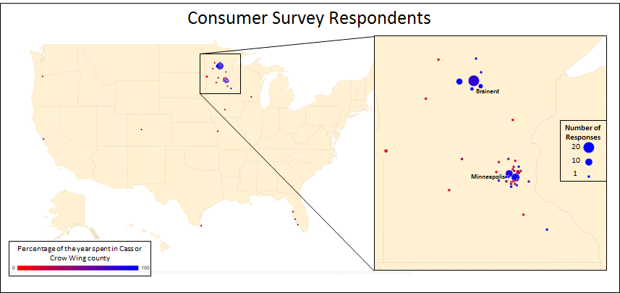 The Consumers Survey received 139 responses from across the country. To better visualize the makeup of the respondents, the map below shows the zip code location of the permanent address of each respondent as well as the percentage of time a year spent in Crow Wing and Cass County. One can see, a majority of the responses were from consumers in Minnesota. Amongst these Minnesotan responses, the time spent in Crow Wing and Cass counties ranged from 2% of the year to 100%. There were ten responses which came from outside of the state of Minnesota. These consumers spent between 19% and 50% of the time in Crow Wing and Cass counties.
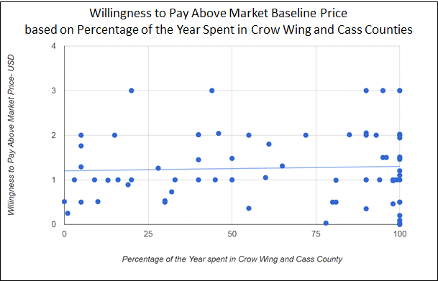 To understand how respondents’ time spent in Crow Wing and Cass counties affected their willingness to pay above market baselines and influenced their preferences in value-added beef qualities, Figure 5.2 and Figure 5.3 were produced. Figure 5.2 shows a regression analysis of the percentage of the year spent in Crow Wing and Cass counties and a respondent’s willingness to pay above market baselines. With an R-Squared of less than 0.002, which explains a large variation away from the best fit line, and a significance of 0.697, which shows a high level of uncertainty in the regression results, we can determine percentage of the year spent in Crow Wing and Cass counties is not a reliable factor in a respondent’s willingness to pay above market baselines. In other words, permanent residents and vacationers to the area have a similar distribution of willingness to pay above market baselines for additional qualities in their beef.
Despite having no significant difference between willingness to pay above market baselines based on time spent in the region, the percentage of the year a respondent spent in Crow Wing and Cass counties was influential on preference in additional value-added beef qualities (Figure 5.3). Much like the dot survey results, consumers reported interest in buying beef with ‘grass-fed’ and ‘local production in Crow Wing and Cass counties’ as additional qualities across all groups. Interestingly, the groups that spend the most time and the least time in the regions reported the highest interest in the environmentally designated qualities of ‘Water Quality Standards’, ‘Land Quality Standards’, and ‘Produced within my Watershed’.
Again agreeing with the Dot Survey results, the most predominant main motivator in respondents’ beef purchasing are ‘Price’ and ‘Qualities I see in the Specific Cut’ (Figure 5.4). This again emphasizes the importance of these qualities in the marketplace. Consistently, the third most predominant main motivator is grass-fed regardless of time spent in the region.
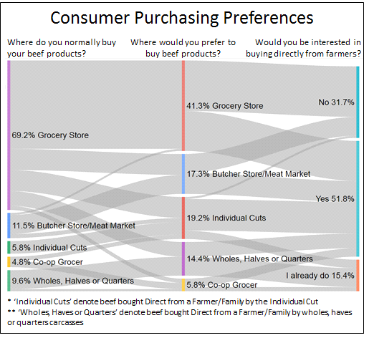 Lastly, Figure 5.5 expresses the methods of beef purchasing in the marketplace. Almost 70% of the consumers who responded denoted they were currently buying beef from grocery store. Although 59.7% of respondents who are currently purchasing beef at the grocery store said the grocery store was their preferred means of beef purchasing, 40.3% of the group expressed desires to purchase beef through a different vendor. Twenty-eight percent of the group currently purchasing beef at the grocery store would prefer to buy beef from a butcher store/meat market or individual cuts directly from farmers. Despite changing the market at which they purchase their beef, groups who desire to buy beef from the grocery store, a butcher store/meat market or individual cuts directly from farmers are consumers who reported concerns about buying beef in bulk. For these consumers, volume was reported as a concern in both amount consumed and storage space. Additionally, only 31.7% of the market reported having no interest in buying directly from farmers. This proves to be an interesting result, since even consumers who prefer to purchase beef from a grocery store or meat market are reporting having interest in buying directly from farmers. Although this might show a misconception in the questions intention, a high interest in buying directly from farmers is reflected in a high interest in ‘Local Production in Crow Wing and Cass counties’ as an additional value-added quality.
Additional Survey results are available in Appendix E and were considered in the Recommendation section.

6.1 Producer and Business Owner Interview Methodology
This study utilizes over the phone interviews with farmers, business owners, and other persons who are a part of the local food supply chain in Crow Wing and Cass Counties. Before the interviews, questions were developed to address topics relating motivations to farm or buy local products, perception of the local beef market, and observed and desired changes. The interview guide used is identified in Appendix F. A semi-structured interview allowed researchers to expand on the topics discussed above as farmers and business owners while gave more depth to responses provided by survey results. During the interviews, the interviewer was responsible for asking questions and writing contact notes. Because interviews were recorded, interviews were reviewed and further analyzed for patterns between responses.
Farmers, business owners, and other persons a part of the local food supply chain in Crow Wing and Cass Counties were recruited from existing relationships through Cass County Farm Bureau and the Happy Dancing Turtle Institute. Acknowledging potential biases, producers with differing size and production styles were interviewed. All non-producers interviewed are currently a part of the local-food supply chain. Before interviewing began, all interviewees gave verbal consent to the interview and its content.
6.2 Producer and Business Owner Interview Results and Discussion
As mentioned above, interviewees represented producers of different sizes and operation type, as well as restaurant chefs, food hub managers, and persons a part of healthcare services. This large expanse of people not only gave a well-rounded perspective of production in Crow Wing and Cass counties but also an idea of the marketplace and consumer preference. There were two large domains, which were discussed by every interviewee: (1) the perception of current market and the importance of value-added qualities, and (2) barriers for the future and how to overcoming them.
Since all of the interviewees were recruited through relationships, which already existed, with the Cows for Clean Water team, the perception of the current market and production paradigm was fairly consistent. Interviewees often discussed the desire to produce or use product which are rooted in social value. Although both producers and purchasers identified the importance of community and keeping food dollars in the area, producers were much more likely to discuss the importance of production standards relating to water and the environment. This importance of purchasing locally for consumers aligns closely with research discussing consumer perception of local. Because consumers often associate local with small family farmers and sustainable practices, the expectations of ‘local’ have come to the forefront of consumer perception. A food hub manager or chef’s market realization for local beef might be rooted in a consumer’s desire to have these other ‘assumed’ qualities.
When asking producers which value-added qualities are used to market their beef, many struggled, and explained ‘knowing the producer’ and ‘knowing how the beef was produced’ was more important to their consumer. Despite the producers discussing the importance of water quality and environmental standards when raising their beef, most of the sales, even sales to restaurants and grocers, were described as ‘word of mouth’ and the consumer’s main desire was to know from where their beef was coming. This again showed a split between consumers’ perception and the added-values to which producers are raising their beef. A marketplace over saturated with labels was often discussed as the reason for this gap. Knowing where their beef was produced was perceived to be better than labels by their customers. Additionally, producers and food hub managers saw this gap as an opportunity to educate consumers and discuss the importance of value-added qualities. Lastly, interviewees often perceived the order of consumer’s preference in qualities as: price, qualities in the meat and then social or environmental impact. Producers and food hub managers reported a portion of consumers losing interest in the market after realizing cost despite reporting high consumer satisfaction. These perceptions match the results seen in survey results.
To understand the steps moving forward, it is first important to identify the perceived barriers in the marketplace. One of the interviewees discussed the barriers of education and access as the main barriers for consumers. Throughout both producer and purchaser interviews these barriers were often repeated. Education was the most commonly discussed barrier for both producers and consumers. One producer discussed the importance of university and farming organizations outreach and educational programs saying, “[producers] can’t do what they don’t know.” He explained these programs cannot only educate producers on the environmental and pasture impacts, but must stress the economics and profitability at the end of the year. Furthermore, he discussed the importance of a neighbor being successful first--many producers discussed being a role model for other producers and being successful as a driving force. As discussed earlier, interviewees see selling directly as an opportunity to educate consumers through long term relationship building.
In addition to educational barriers, both producers and consumers identified market access as a major barrier. A healthcare provider discussed her work with low income, health-at-risk families not only as breaking down institutional silos and bring food to the forefront, but developing accessibility for her patients. She discussed the importance of making farmers markets and buying-direct more comfortable. Many consumers can buy local products but have not received access to the market. She and a food hub manager discussed the embedded mindset of shopping at the grocery store. This mindset was described as an additional barrier by the food hub managers since grocery stores offer a level of convenience, which is hindered by the forethought required to buy direct. He saw the best route forward as a storefront that offers the convenience expected by consumers. Access to the marketplace is also a problem for producers. The main accessibility barrier discussed by producers was the availability and affordability of processing. Producers gave the most varied response when discussing processing. Some slaughtered all USDA inspected despite selling direct-to-consumer or to an institution, others only looked to sell direct-to-consumers and only used custom exemption processing, and some used a mix based on the final consumer. Despite their current process, many discussed the difficulties of getting animals to slaughter and the large disadvantage of not reaching an economy of scale. To combat the processing barrier, producers proposed changing regulation that would change the inspection requirement based on size, discussed moving farm sites closer to processing facilities, expressed the need for developing a market for slaughter bi-products, and others discussed continuing their current process with no change. Lastly, producers as well as purchasers often discussed the difficulty of producing or receiving high quality, fresh beef year round in a grass-fed system. Chefs and school dining managers identified both consistency in product and timing as an important factor to integrating local product into menus. This gap between consistencies of supply and demand is seen as barrier in the market for institutions with consistent demands.
Recommendations
7. Value-Added Qualities in the Marketplace
When assessing the importance of value-added qualities in the marketplace, there are two main factors to consider: consumer interest and association with willingness to pay. In all survey cases, price and qualities seen in the meat were proven to be the two main motivators. These results were reflected in producer and market manager interviews. When removing these main two motivators, grass-fed and local production in the Pine River Family Market dot survey and in all four groups of the consumer survey were expressed as being top motivators. These two qualities also received the largest responses for desired additional, value-added beef qualities. The consistency of these results shows a strong trend in the market. Branding as local and/or grass-fed will bring the largest potential for drawing in customers. After considering overall consumer interest, one must consider the group's willingness to pay. In all cases, consumers were willing to pay the most above market prices when considering environmental qualities, such as land and water standards.
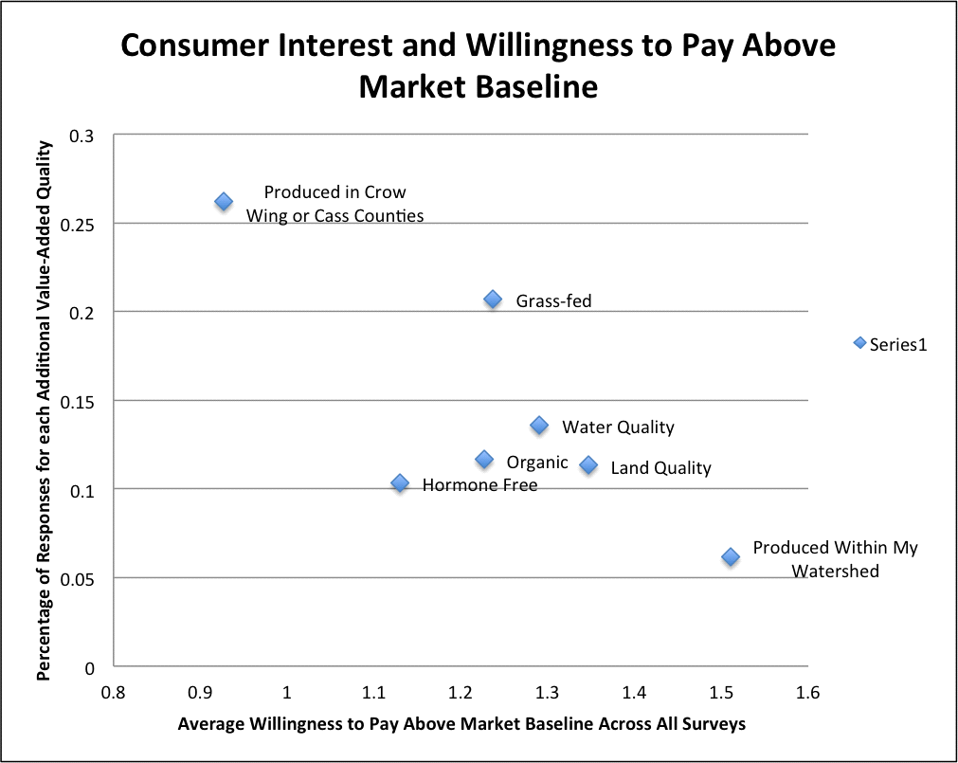Figure 7.1 is an attempt to visualize the potential tradeoffs between consumer interest and association with willingness to pay. With the percentage of responses for each additional, value-added quality on the y-axis and the average willingness to pay above market baseline prices across all surveys on the x-axis, the most ideal quality would be in the top-right corner. The top right corner represents high market interest and high willingness to pay above market baseline prices. Value-added qualities near the top-left corner, products ‘produced in Crow Wing and Cass counties’, have the highest demand in the marketplace but fetch the smallest mark-up in cost. The bottom-left corner, products ‘Produced within my watershed’, has the lowest demand but hold the highest potential mark-up. Even though these additional value-added qualities would most likely represent the same producer group geographically, there connotation for consumers leave them at opposite ends of the niche market spectrum. These results again show ‘local production’ and ‘grass-fed’ as the two most accessible niche markets for consumers. In a developing market, these two qualities should drive initial sales. Additional value-added qualities could be developed overtime as consumers warm to the value-added market and could be main educational points with early consumers.

8. Co-op Formation
The second recommendation moving forward is Cooperative formation. There are four distinct advantages a a co-op would provide the beef producers of Crow Wing and Cass counties, which are: (1) increase product flow, (2) processing bargaining, (3) collective marketing, outreach and education skills, and (4) local branding.
First, with producers providing beef products through the same entity, product flow increases and allows for entry into larger institutional markets. Since many producers a part of this study finish 40 or less animals a year, cooperation is required to offer consistent supply to the market. Currently, a few producers are able to supply the needs of local restaurants. If desire for local meat products continues to increase as anticipated by area chefs, consistency in product delivery and quality will drive a need for a collective product flow. Because specific cuts can still be offered as specials at restaurants, consistency and volume of products for restaurants are still lower than the product flow required for other institutions like grocers, hospitals or schools. To enter these markets, cooperative product flow becomes increasingly important. Successful examples of coops collectively selling beef to institutions in Ohio and New York are discussed in the ‘Co-op Formation’ section.
Second, the co-op is an entity that can collectively bargain for members. Much like the original farmers coops in the 1800s, forming a co-op would allow better bargaining for future project grant money or lower prices at the processing facility. Facility availability and accessibility was at the forefront of producer’s interviews and has been discussed in literature as a main barrier to success. With an increased number of animals being brought into processing, the co-op is able to leverage towards their collective interests. Cooperatives are seen as a means to shift power back into the producer's control.
Third, successful cooperatives allow farmers in the group to work with each other's best assets. Some producers have natural talent or have been trained to do marketing, outreach or education for consumers. Some of the most successful beef co-ops are ones that allow each farm to play to their strengths. Throughout the interviews, many producers discussed marketing relying on word of mouth. To realize the potential market outlined in the research above, producers will have to work harder to market to new consumers through different sales streams. By creating a co-op with the power and specialization to find and pursue these market streams, the market will expand at a more rapid pace. Producers also identified the importance of teaching consumers the importance of water quality and environmental standards in the production system. Through the co-op producers have the opportunity to deliver clear and consistent educational messaging throughout the region. In addition, collective educational messaging would decrease an individual farmer’s time spend on educational components.
Lastly, the formation of a co-op could be the first step in a locally identified brand. A local or regional brand can have remarkable impacts on rural communities. The ASAP Appalachian Grown: Certified Local program and label has driven a 70% increase in direct sales between 2007 and 2012. Although the branding and certification process will take a large amount of time during initiation and potentially additional time yearly, a regional certification process could propel local grower off the strong community interest in the region. In addition to branding as local, the co-op could require specific certifications such as GAP Certification or Minnesota Agriculture Water Quality Certification, which could drive market access into institutions and be a consumer educational component respectively. By creating a local certification or label through the co-op, the co-op would retain the ability to improve or change the requirements of their members. Branding as the Brainerd lakes region might be the most important marketing ploy. Value-added labels such as ‘grass-fed’ and ‘hormone free’ offered the highest willingness to pay above market baselines, but local identification consistently drew the most customers. With a marketplace saturated with value-added labels, locality has shown to be the most eye catching in the marketplace. These additional labels should be secondary or a part of the brands story.
With any benefits, there are also drawbacks. By creating a co-op, there are two inherent drawbacks. First, by creating a co-op there are lessons to be learned from Annie Wilson and Tallgrass Prairie Producers Co-op. Her story is outlined in more detail in the ‘Coop Formation’ section. She discusses the importance of understanding the additional demands running a co-op brings to the members. There is obviously the time required to manage the business but also the money required for operations and infrastructure (even the additional cost of printing the label itself). Second, many producers and consumers identified the market drivers of ‘wanting to know their producer’ and ‘wanting to know where their beef was raised’. It is important to consider the disadvantages of giving up anonymity of individual producers before considering a unified and consistent label. There is of course ways to reduce this disadvantage in the co-op’s business strategy. Producer members may decide to only market to institutions using the regional label while allowing for continued direct-to-consumer sales. The specific strategy of the co-op should be discussed thoroughly to identify the best interests of the producer involved.

9. Market Opportunities
After reviewing both the consumer and producers surveys, dot surveys and interview transcripts, two market avenues become most appealing at this time. First food hub managers discussed the importance of fitting into the current purchasing paradigm of consumers in the region. Entry into local grocery stores is a potential point of entry into the market for local consumers. A majority of local consumers identified the grocery store as their preferred location to purchase their beef products. In the same survey, nearly half of the consumers who identified the grocery store as their preferred location to purchase their beef products denoted they were interested in purchasing beef direct from producers. In addition, grocery store groups were the most likely to show the highest willingness to pay above market baseline for value-added beef qualities throughout all surveys. The three major concerns for buying direct in this group are quantity of bulk meat purchases, quality of processing and convenience. By selling through grocery stores, these concerns are effectively addressed through the sale of individual cuts, the use of USDA processing and packaging, and availability at local retailers. Unified and recognized branding as well as consistent product flow is important in single cut sales.
Through the dot survey and the consumers survey the number of consumers with permanent residences outside of Crow Wing and Cass counties became apparent. These consumers are often absent from the beef market in local grocery stories. Although the premeditation of buying online direct was identified as a major barrier in local markets, expanding the online market to vacationing families or groups could develop this disadvantage into an advantage. Survey respondents that identified spending the least amount of time in the region were the most interested in buying direct from producers in ‘vacation packages’ or bundled beef packages (like Meat Healthy). By creating an association with vacationing in the region, bundled meat sales could develop into a vacation associated luxury. This group was also the group most interested in buying roasts and other non-prime cuts. Producers identified problems selling cut that were not prime cuts or hamburger. Roasts had to be ground into hamburger since there was no market. Bundled beef sales will develop a market for roasts and other non-prime cuts increasing profit margins per head. In both the consumers and producers surveys, grocery stores and butcher shops/meat lockers are identified as the preferred drop-off/pick-up locations. This scenario offers market expansion to new consumers and more profit for producers, but producers are forced to be more active in marketing, packaging and delivering. New relationships will need to be developed between producers and drop-off locations, which could require a payment or profit sharing.
An important yet potentially less successful market is wholesale markets through restaurants and schools. Solidifying these markets could bring large amounts of demand to drive producers’ supply, but entry has been explained to be difficult. Many interviewees identified restaurants as an important place for market entry for consumers. It is perceived that consumers are able to first interact with value-added beef at restaurants, which drives a consumer's desire to purchase value-added beef individually. Although these perceptions may be true, the restaurant market is already supplied by a few producers. More producers entering the restaurant market without expanding the restaurant's demand will increase internal competition in the marketplace. To expand these markets, more effort is required in developing restaurant interests in providing value-added beef options. As explained by one chef, restaurants must drive the value-added beef market by offering it on the menu as well as being responsive to current trends. Convincing chefs to drive the market rather than being responsive poses a large barrier. The demand barriers of restaurants are simpler than demand barriers observed in farm-to-school programs. Farm-to-school markets are made more complicated by procurement policies and structured budgets. School dining service managers explained their main local; produce provider sells bumper crops to the school after supplying other markets. In this scenario, local farmers are selling products below market costs since profits are already achieved through other markets. Additionally, the desire to purchase locally may be diminished due to procurement processes where funding is offered through direct product delivery rather than cash reimbursement for purchases. As one school dining service manager explained, “no matter how much I want to buy from local farmers, the commodity food that I receive from the government always fits into my budget better than the stuff I need to buy.” The combination of market uncertainty and slim school budgets may make developing a value-added beef, farm-to-school market difficult.

Appendix A- Local beef dot surveys at grocery stores.

- How much will you or have on on average do (Changed Mar. 22nd) you spent on beef today per shopping trip?
- $0
- $1-$10
- $10-20
- $20-$30
- $30-$40
- $50+
- What is the main motivator in your beef selection?
- Price
- Local production
- Grass-fed
- USDA Certified Organic
- Impact on Environment (land and water)
- Qualities I see in the specific cut (i.e. marbling or color)
- If you had the option, what additional (Changed Mar. 22nd) qualities would you like to see in your beef selection?
- None
- Local production
- Grass-fed
- Organic
- Produced to meet a certified Water Quality Standard
- Produced to meet a certified Land Quality Standard
- Produced in Crow Wing and Cass Counties
- Identification of Local Farmer
- On average, if a cut of beef was $3.00/lb, how much would you pay for the cut to also have the qualities you specified in the last question?
- $5.00/lb
- $5.25/lb - $5.50/lb
- $5.51/lb - $6.00/lb
- $6.01/lb - $6.50/lb
- $6.51/lb - $7.00/lb
- $7.01/lb - $7.50/lb
- $7.51/lb - $8.00/lb

Appendix B- Consumer Survey Questions:

- Where do you normally buy your beef products?
- Grocery Store
- Butcher Store/ Meat Market
- Co-op grocer
- Direct from a Farmer/Family (individual cuts)
- Direct from a Farmer/Family (Whole, halves, or quarters)
- I don’t buy beef
- How often do your purchase beef?
- Once per week
- Once per month
- Once every several months
- Once per year
- When you purchase beef, how much do you normally spend on beef?
- $1-$20
- $20-$40
- $50-$100
- $100-$250
- $250-$500
- $500+
- What is the main motivator in your beef selection?
- Price
- Local production
- Grass-fed
- USDA Certified Organic
- Impact on Environment (land and water)
- Qualities I see in the specific cut (i.e. marbling or color)
- If you had the option, what additional quality would you like to see in your beef selection? (Select all that apply)
- None
- Grass-fed
- USDA Certified Organic
- Produced to meet a certified Water Quality Standard
- Produced to meet a certified Land Quality Standard
- Local production in Crow Wing and/or Cass Counties
- Produced in your watershed
- Where would you prefer to buy beef with the quality indicated in question #5?
- Grocery Store
- Butcher Store/ Meat Market
- Co-op grocer
- Direct from a Farmer/Family (individual cuts)
- Direct from a Farmer/Family (Whole, halves, or quarters)
- On average, if a cut of beef was $5.00/lb, how much would you pay for the cut to also have the qualities you specified in question #5?
- $5.00/lb
- $5.25/lb - $5.50/lb
- $5.51/lb - $6.00/lb
- $6.01/lb - $6.50/lb
- $6.51/lb - $7.00/lb
- $7.01/lb - $7.50/lb
- $7.51/lb - $8.00/lb
- If you do not already buy directly from farmers, would you be interested?
- I already buy direct
- Yes, I want to learn more
- No, I’m not interested
- If you answered no to question #8, what are your concerns with buying direct?
Open comment - (if they answer no to question # 8, send them to #13)
- What direct purchasing models would you be interested in purchasing?
- Wholes, Halves or Quarters of an Animal
- Weekend Bundle Baskets (i.e. 4 steaks, a roast, and hamburger)
- Vacation Bundle Basket (i.e 6-8 steaks, 2 roasts and hamburger)
- Individual Cuts
- How would you prefer to buy directly from farmers?
- Online through an website
- Online through email
- Over the phone
- By Mail
- What is the preferred pick-up method?
- At drop-off site
- Local grocery store
- Restaurant
- Farmer’s market
- At the farm
- At the Butcher Store/ Meat Market
- What cuts of beef would you be interested in buying? Check all that apply.
- Roast
- Hamburger
- Short Ribs
- Prime Rib
- Steaks
- Tenderloin
- Other:_____________
- What percentage of the year do you spend in Cass or Crow Wing county?
- Zip code of permanent address
- Open comment -
- If you want to be entered to win one of the coupons for local grass-fed beef, please include or get in contact with local beef producers, please include your email below. Thank You!

Appendix C- Producer Survey Questions:

- Do you produce beef products in Cass County or Crow Wing County?
- Yes
- No [GO TO CLOSING]
- How would you describe your production system? (Select all that apply)
- Cow-calf production
- Finishing for Market
- Calving through Finishing
- Other: [TEXT ENTRY]
- Where do you market your beef products? (Select all that apply)
- Grocery Store
- Butcher Store/ Meat Market or Locker
- Co-op grocer
- Direct to Consumer
- Beef Auctions/Sales
- Restaurants
- Institutions or Schools
- On average how many beef animals are you rearing a year?
- 1-20
- 20-40
- 50-100
- 100-250
- 250-500
- 500+
- Do you finish your beef animals?
Yes [GO TO FINISHING DETAIL]
No [GO TO HURDLES]
- If you are finishing animals, in which months are you bring animals to market? [MULTI-SELECT]
- January
- February
- March
- April
- May
- June
- July
- August
- September
- October
- November
- December
- At slaughter, what is their average market weight? (700-1700 pounds)
- What is your average total cost to raise an animal to market weight (including labor, land, feed and vet costs)? (900-2300)
- On average, how much are you receiving per pound carcass weight for your animal or finished weight?
$___________/lb carcass or $___________/lb processed and packaged
- What are your largest hurdles in your production system? Please describe in the space provided below.
- What qualities do you market in your beef product? Check all that apply.
- Price
- Marbling Premiums (Select, Choice ,Premium, etc.)
- Local production
- Grass-fed
- Organic
- Produced to meet a certified Water Quality Standard
- Produced to meet a certified Land Quality Standard
- Produced in Crow Wing and Cass Counties
- Identification of Local Farmer
- Local processings
- If you had the option, what qualities would you like to see marketed or better marketed in your beef product? Check all that apply.
- None
- Local production
- Grass-fed
- Organic
- Produced to meet a certified Water Quality Standard
- Produced to meet a certified Land Quality Standard
- Produced in Crow Wing and Cass Counties
- Identification of Local Farmer
- Would you consider adding any of the following qualities to your production system? Check all that apply.
- None
- Grass-fed
- Organic
- Produced to meet a certified Water Quality Standard
- Produced to meet a certified Land Quality Standard
- Produced in Crow Wing and Cass Counties
- Do you prefer fresh or frozen product?
- Fresh
- Frozen
- On average, if you were paid $3.00/lb carcass weight, how much would you expect to be paid to also have the qualities you specified you would be interested in adding?
- $3.00/lb
- $3.25/lb - $3.50/lb
- $3.51/lb - $4.00/lb
- $4.01/lb - $4.50/lb
- $4.51/lb - $5.00/lb
- Would you be interested in selling directly to consumers, restaurants, or institutions?
- I already sell direct to: ______________ [GO TO DIRECT DETAIL]
- Yes, I want to learn more about selling to: _______________ [GO TO DIRECT DETAIL]
- No, I’m not interested [GO TO Q16/DIRECT CONCERNS]
- What are your concerns with selling direct?
- How would you prefer to sell directly?
- Online through an website
- Online through email
- Over the phone
- By Mail
- What is the preferred pick-up method?
- At drop-off site
- At the farm
- At the Butcher Store/ Meat Market

Appendix D- Producer Survey Results

Above Figure A1 | Below Figure A2

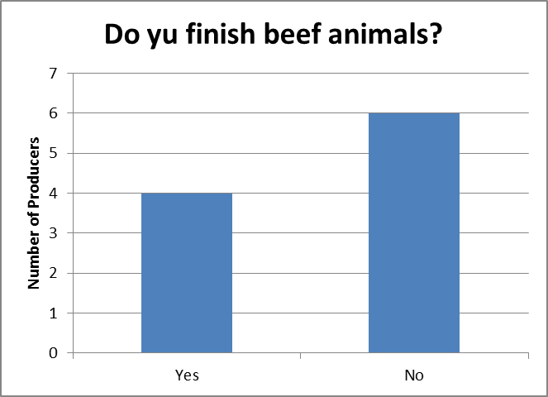
Above Figure A3 | Below Figure A4

Average market weight of animal at slaughter (in USD)
Minimum | Mean | Maximum | Std Dev | Variance | Count
995.00 | 1175.25 | 1362.00 | 141.31 | 19967.19 | 4
Average total cost to raise a beef animal
(including labor, land, feed and vet costs) (in USD)
Minimum | Mean | Maximum | Std Dev | Variance | Count
902.00 | 1172.00 | 1493.00 | 216.99 | 47085.50 | 4

Average per pound Carcass Weight (in USD)
Minimum | Mean | Maximum | Std Dev | Variance | Count
2.60 | 2.93 | 3.18 | 0.21 | 0.04 | 4
Average per pound Finished Weight (in USD)
Minimum | Mean | Maximum | Std Dev | Variance | Count
3.25 | 4.63 | 6.00 | 1.38 | 1.89 | 2

Above, Top to Bottom Table A1, Table A2, Table A3 and Table A4 | Below Figure A5

Above Figure A6 | Below Figure A7

On average, if you were paid $3.00/lb carcass weight, how much would you expect to be paid to also have the qualities you specified you would be interested in adding?
Minimum | Mean | Maximum | Std Dev | Variance | Count
3.28 | 3.90 | 4.10 | .28 | .008 | 6
Top Figure A8 | Middle Table A5 | Bottom Figure A9

Above Figure A10 | Below Figure A11

Appendix E- Additional Consumer Survey Results

Anova: Single Factor - Willingness to Pay Above Market Baseline for Additional Value-Added Beef Qualities
SUMMARY
Groups | Count | Sum | Average | Variance
none | 16 | 19.79 | 1.23687 | 0.68641
Grass-fed | 34 | 45.2 | 1.32941 | 0.578757
USDA Certified Organic | 20 | 22.38 | 1.119 | 0.672494
Water Quality | 25 | 38.87 | 1.5548 | 0.683634
Land Quality | 24 | 41.34 | 1.7225 | 0.815802
Local production in Crow Wing and/or Cass | 35 | 48.88 | 1.39657 | 0.66697
Watershed | 8 | 7.54 | 0.9425 | 0.379221
ANOVA
Source of Variation | F | P-value | F crit
Between Groups | 1.735079 | 0.116299 | 2.15752
Table A6 | *Since - F Crit < F < F Crit we fail to reject the null hypothesis and accept that the groups are not statistically different.

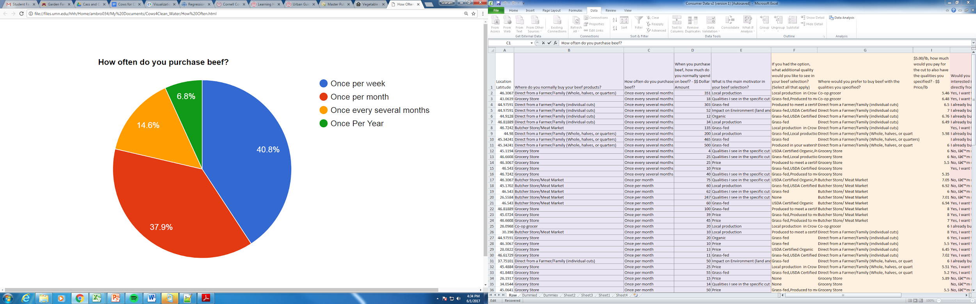
Figure A12 Above | Figure A13 Below

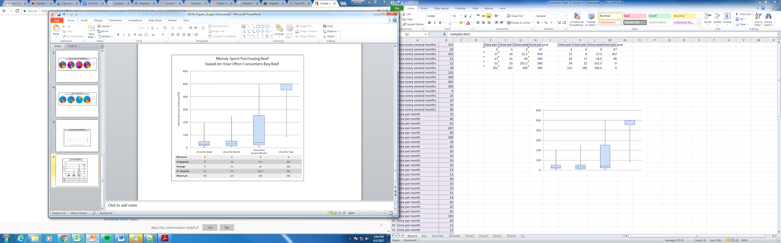
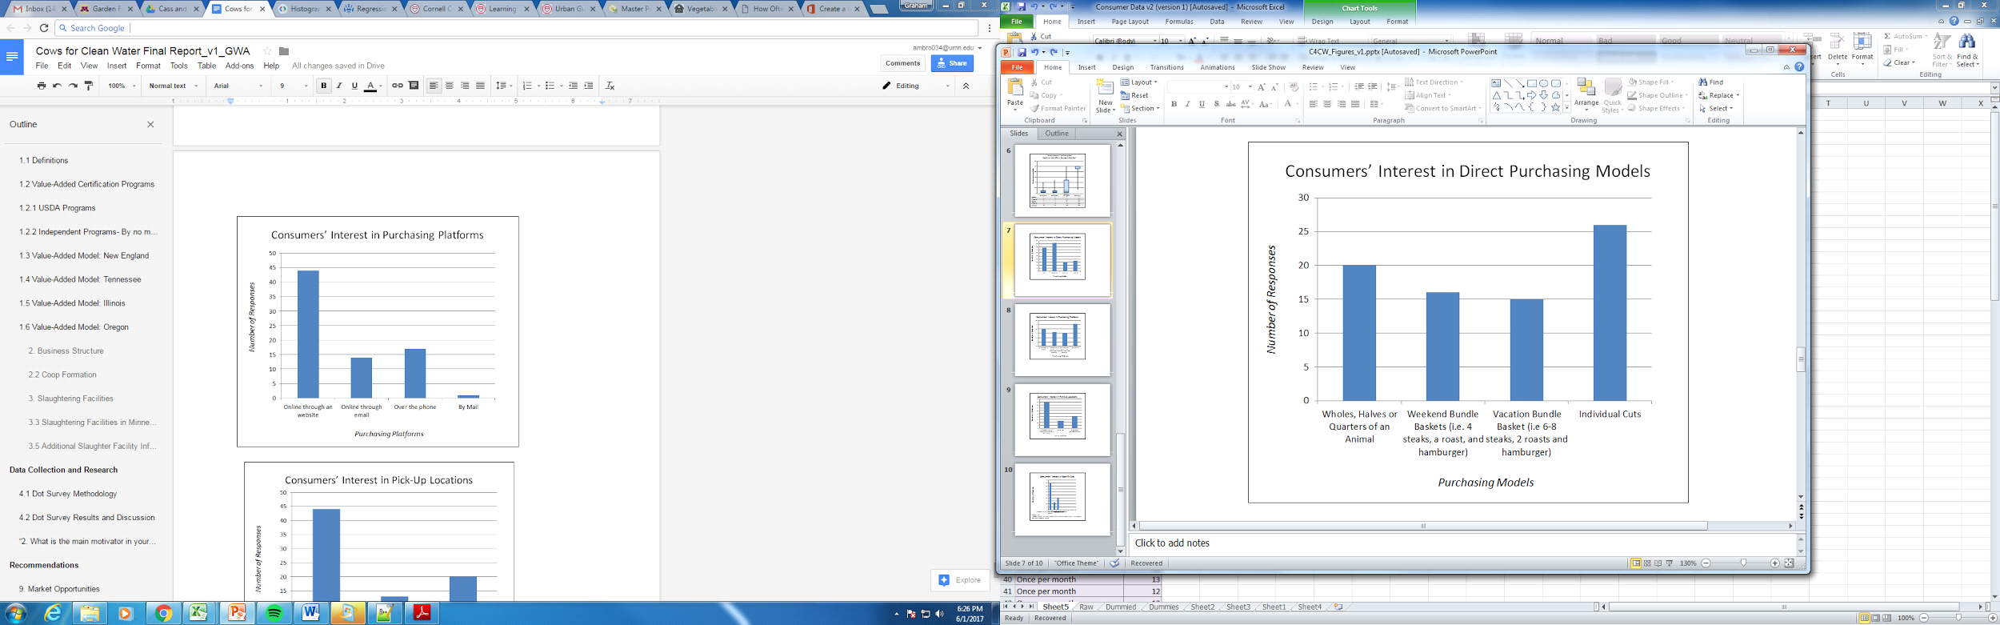
Figure A14 Above | Figure A15 Below
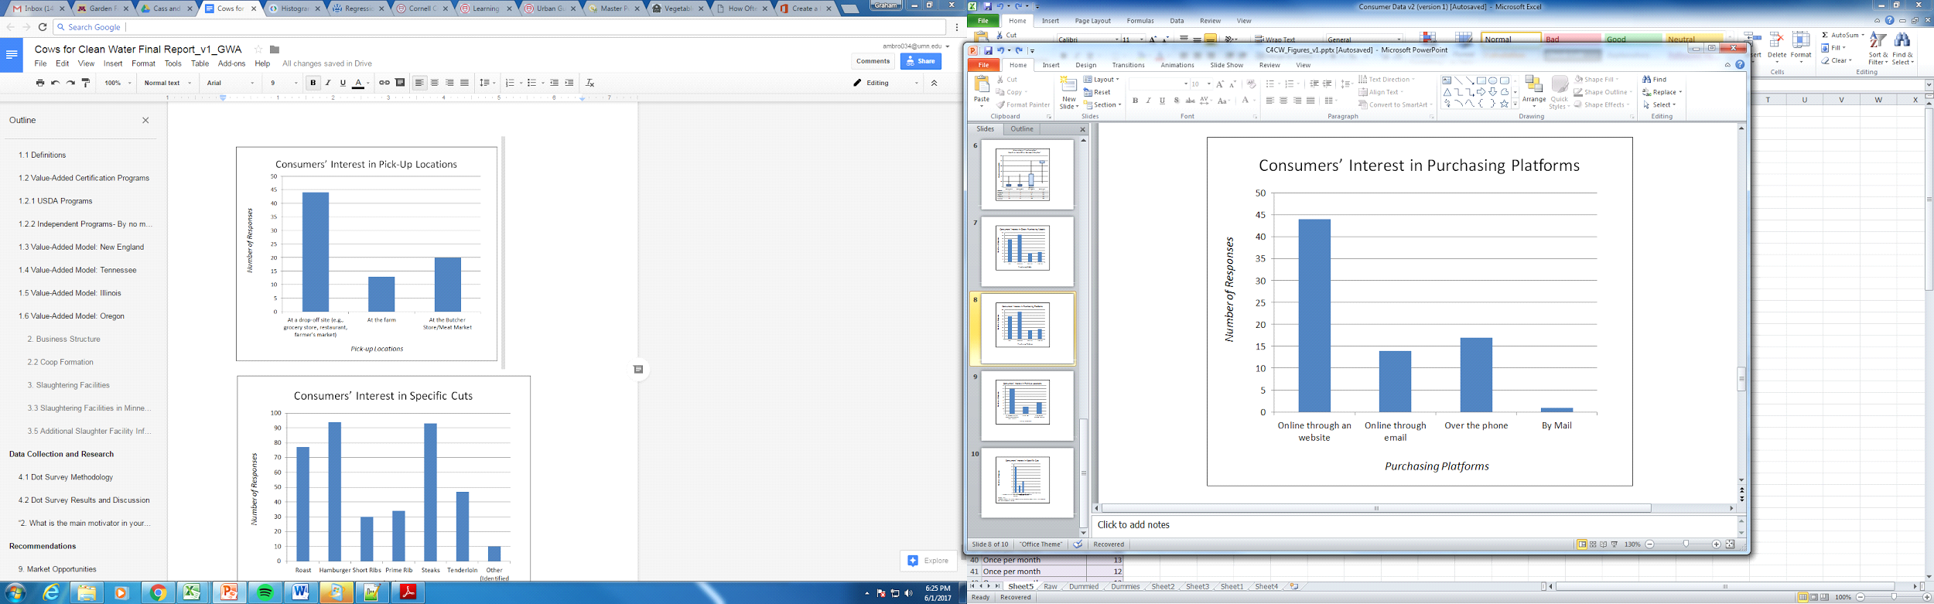
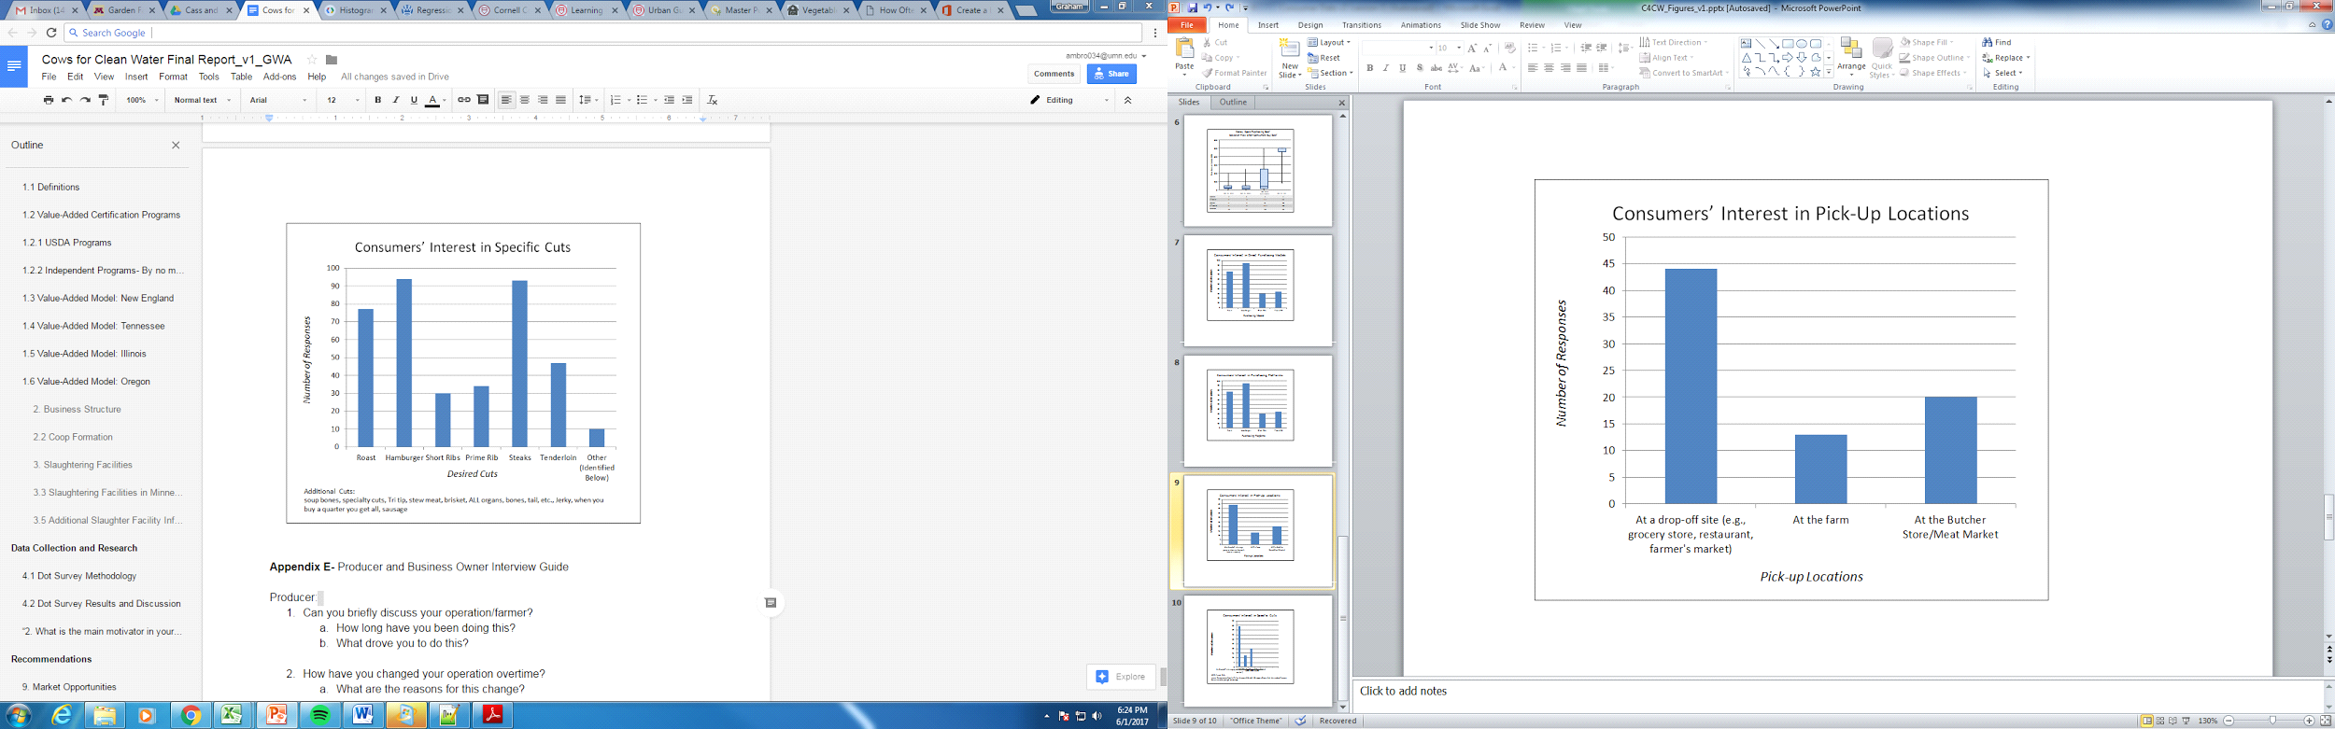
Figure A16 Above | Figure A17 Below

Appendix E- Producer and Business Owner Interview Guide

Producer:
- Can you briefly discuss your operation/farmer?
- How long have you been doing this?
- What drove you to do this?

- How have you changed your operation overtime?
- What are the reasons for this change?

- Can you discuss any changes you have in mind for the future?
- What makes you consider these changes?
- What needs to happen for you to consider changing your operation?

- What qualities do you produce for in your beef?
- Why these qualities?

- What qualities do you market to consumers?
- Why these qualities?
- Are there any qualities you produce for but you feel like you marketing?
- Why do you believe you can’t market these qualities?

- Have you ever Marketed direct to consumers or through a local grocery store or butcher?
- YES
- Can you discuss this experience?
- What are the advantages/disadvantages?
- What is the potential for this market in the future?
- Barriers?
- NO
- Can you discuss what the barriers for you are with direct sales?
- What do you see as advantages/disadvantages?

Market Manager/ Business Owner:
- Can you briefly discuss your operation/business?
- How long have you been doing this?
- What drove you to do this?

- How have you changed your business overtime?
- What are the reasons for this change?

- Can you discuss any changes you have in mind for the future?
- What makes you consider these changes?
- What needs to happen for you to consider changing your operation?

- How have consumer changed over time?
- What qualities do you market to consumers?
- Where do you see the market going?
- What are the barriers to this happening?

